Chapter 7 programming practice

# linked list disk allocation algorithm

Given the common.h

## Common.h

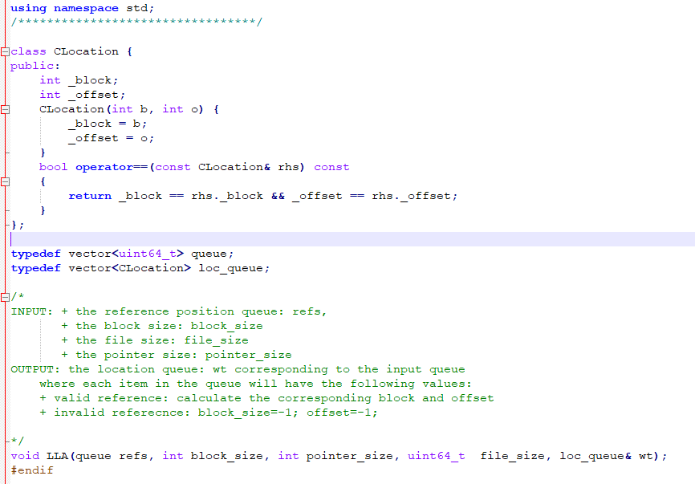

The procedure Access is what you have to program.

/*

INPUT: + the reference position queue: refs,

+ the block size: block_size

+ the file size: file_size

+ the pointer size: pointer_size

OUTPUT: the location queue: wt corresponding to the input queue

where each item in the queue will have the following values:

+ valid reference: calculate the corresponding block and offset

+ invalid referecnce: block_size=-1; offset=-1;

*/

## void LLA(queue refs, int block_size, int pointer_size, uint64_t file_size, loc_queue& wt);

## main.cpp

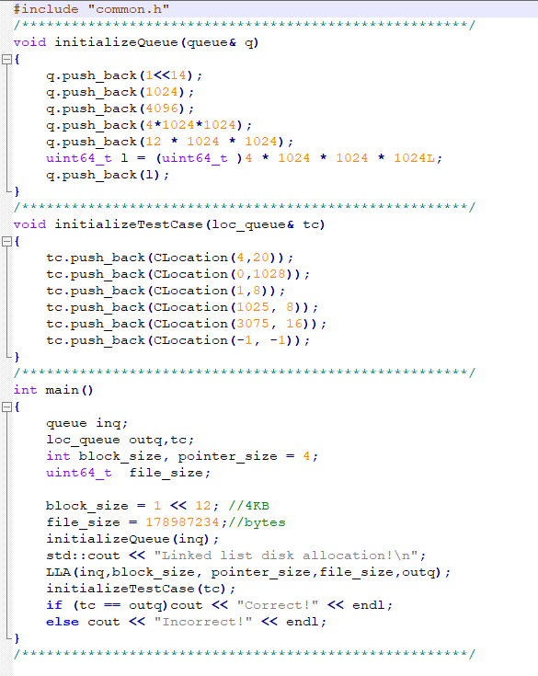

This contains the variable declaration and test case.

## Makefile

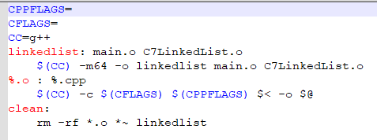

# Problem

Write the void void LLA(queue refs, int block_size, int pointer_size, uint64_t file_size, loc_queue& wt); procedure in the C7LinkedList.cpp file